# User Documentation

**Team**: Healthcare Solutions Team

**Author**: Zachery Q. Brunner [**Zachery.Brunner@BlueKC.com**](mailto:Zachery.Brunner@BlueKC.com)

**Script**: Script2 ADO to Word

**Date Created**: 29-Aug-2021

# Table of Contents

Contents

User Documentation 1

Table of Contents 2

Download the Test Suite from Azure DevOps 3

How to Execute from Visual Studio 2019 5

# Download the Test Suite from Azure DevOps

**Step 1**:

Go to Azure DevOps **Test Plans**

**Step 2**:

Select a **Test Suite**



The tests inside the suite will be found on the right panel

**Step 3**:

Select the **Export Test Cases to CSV** button



**Step 4**:

The download will begin. It will download to your **Downloads** folder

**Step 5**:

Open the file explore – go to the **Downloads** folder

**Step 6**:

Rename the file to **Tester_Excel_File**

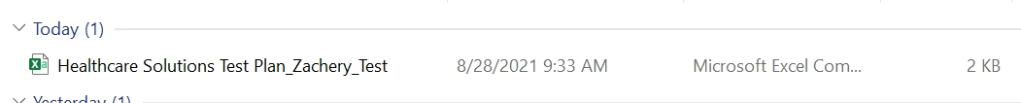

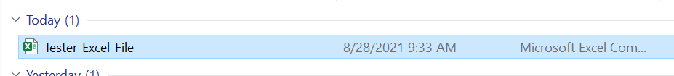

# How to Execute from Visual Studio 2019

**Step 1**:

Click the **Start** button



**Step 2**:

Type **Visual Studio 2019**

**Step 3**:

Open **Visual Studio 2019**

**Step 4**:

Open **Script2 ADO to Word**

**Step 5**:

Navigate into the **Program.cs** file

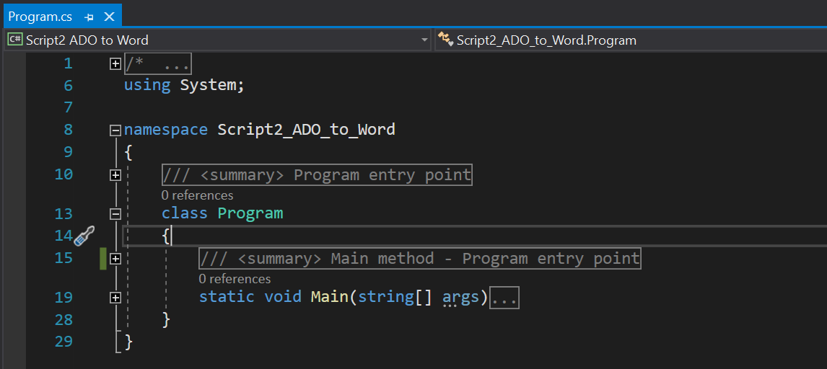

**Step 5**:

Click the **Green Play Arrow**

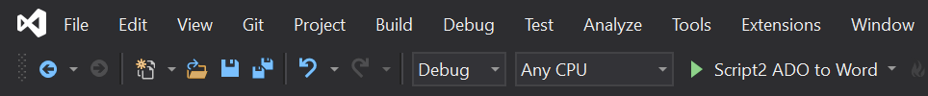

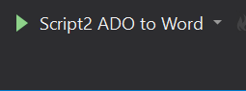

**Step 6**:

**Step 7**:

* If an exception is thrown, please take a picture and send to **Zachery Brunner** [**Zachery.Brunner@BlueKC.com**](mailto:Zachery.Brunner@BlueKC.com)